**Capstone Project**



**Fake product Identification**

﻿

﻿

Student

**101464127-Hemant Kumar Varma Pothuri**

**101460498-Vineeth George**

﻿

Instructor

George Petrovic

Andrew Starling

**Abstract**

Due to the lack of transparency, supply chain management regularly had problems with service redundancy, ineffective departmental collaboration, and lack of standardisation. Nowadays, it's incredibly usual for products to be counterfeited, and it's very impossible to tell if a product is fake just by looking at it. For legal businesses, counterfeiters pose serious obstacles, but there are far too many of them. People are unaware of the full extent of counterfeit products' impact on brands. Various strategies have been developed in the past to circumvent the issue of product counterfeiting. The most common techniques are utilising technologies like RFID tags, AI, QR code-based systems, etc. However, each of them had a few drawbacks, such as the QR code, which may be copied from a real goods and used on a false product, artificial intelligence, which makes use of CNN and machine learning and requires a lot of computer power, and more. By following a product's supply chain history, this research aims to increase the detection of phoney goods. With the help of blockchain technology, which guarantees the identity and traceability of actual products along the supply chain, this is made possible. Everything is decentralised in a blockchain-based system so that multiple parties can access it simultaneously. One of its key benefits is that the data captured can only be changed with the approval of all parties involved, making the information incredibly secure and safe from all.

**Problem**

Product forging happens when an item is sold pre-having a tendency to be another item. It is purchaser extortion also, normally characterized as misleading strategic policies that make purchasers suffer financial or different misfortunes. Fake products are expanding by 20% in the middle between. Fake products include fake shoes, apparel, beauty care products, and hardware. It has negative effects on the economy, however, on citizens as well. For instance, unfortunate beauty care products can affect skin and cause skin sicknesses and rashes, and fake electronic parts can cause a breakdown in devices and can prompt troublesome circumstances and incidents. Low-quality garments, and shoes when worn, can cause uneasiness. Subsequently, this issue requires discovering some answers for the offer of fake items. One more outcome of forging is that an organization's reputation suffers. Since numerous clients are clueless that the item, they are holding is knock off they will blame the real organization if the knock off item fails to perform appropriately, breaks into pieces quickly, or fails to fulfil their assumptions. Client request reward, either as a discount or another item, and they search it out straightforwardly from the authentic organization. A great deal of affected organizations might wind up in a situation where they are managing a troubled client who is griping about the terrible nature of the thing, and the client care delegate is ignorant that the thing in question is a fake. Organizations are gotten between a predicament, endeavouring to abstain from with nothing to do and exertion managing unfortunate impersonations of their products while yet attempting to keep their clients satisfied. The mischief caused by forgers reaches out past client connections. On account of the ways of behaving of forgers, merchants, retailers, and other colleagues much of the time lose confidence in real ventures

**Solution**

The best moderation measures for beating deceiving fake products in worldwide stockpile chains incorporate organization transparency, cost control, and pre-supply assessment approaches, and provider relationships with the executives. Thus the target of this project is to introduce the system is designed for anti-counterfeit using Blockchain technology and to empower end clients and providers to track store network of items in a secured environment. In an outline of the proposed system, it is meant to tackle the issue of brand forging and give the opportunity to the client, sellers, and providers to take a look at the uprightness of the item

**Literature survey**

The survey concentrated on comprehending the origins of counterfeit goods and their societal repercussions. Several approaches for detecting fake products exist, including those utilizing Artificial Intelligence, QR codes, Machine Learning, and Blockchain. Shaik's methods involved embedding public and private keys as QR codes on products. Scanning these QR codes required cryptographic functionality within the scanning app for decryption. The manufacturer's server matched buyer names and item codes. The scanning app also decrypted the item code ciphertext encoded in the QR code [9].Benatia and Baudry et al. introduced a traceability-CPS architecture for supply chain management. This architecture comprised multiple interacting layers that facilitated product traceability. It also enabled supply chain monitoring and data analysis to enhance product safety and quality. Their algorithm involved computing frequent item sets in the product transaction database, which could detect abnormal product behaviour [10]. Khalil and Doss et al. proposed a solution using RFID-based systems to combat counterfeiting. This system allowed consumers to verify item legitimacy by querying the attached RFID tag in stores. Their lightweight scheme was suitable for retail environments and utilized low-cost passive RFID tags [11]. Habib and Sardar et al. discussed supply chain management (SCM) trends. They identified executives' challenges and transaction issues in SCM and proposed blockchain as a solution. They suggested structuring new models around transaction processes at a plan level [12]. Daoud and Vu et al. focused on an AI Application architecture with three main components: the dataset, detection models, and trained models. Their machine learning-based solution detected counterfeit products through training and logo detection steps using Faster R-CNN [13]. Chen and Shi et al. introduced a framework for blockchain-based Supply Chain Quality Intelligence (SCQI). This framework used RFID technology to record quality and transaction information, while smart contracts executed quality control to enhance supply chain efficiency [14]. Toyoda, Kentaroh, and Mathiopoulos, P Takis et al. proposed a QR code-based system for detecting fake products. End users could scan QR codes for product details and transaction history [15]. Blockchain-based systems stored data on each node, with nodes exchanging information. Each node verified transactions, included them in new blocks, and aimed to secure block rights. Ethereum served as the backend operating system, storing product sales data accessible to all [7]. A blockchain technology proposal suggested owner-controlled information sharing, minimizing third-party interference. Blockchain blocks contained sender-receiver details, transaction and product IDs, and metadata [16]

**Project screenshots**

Home page

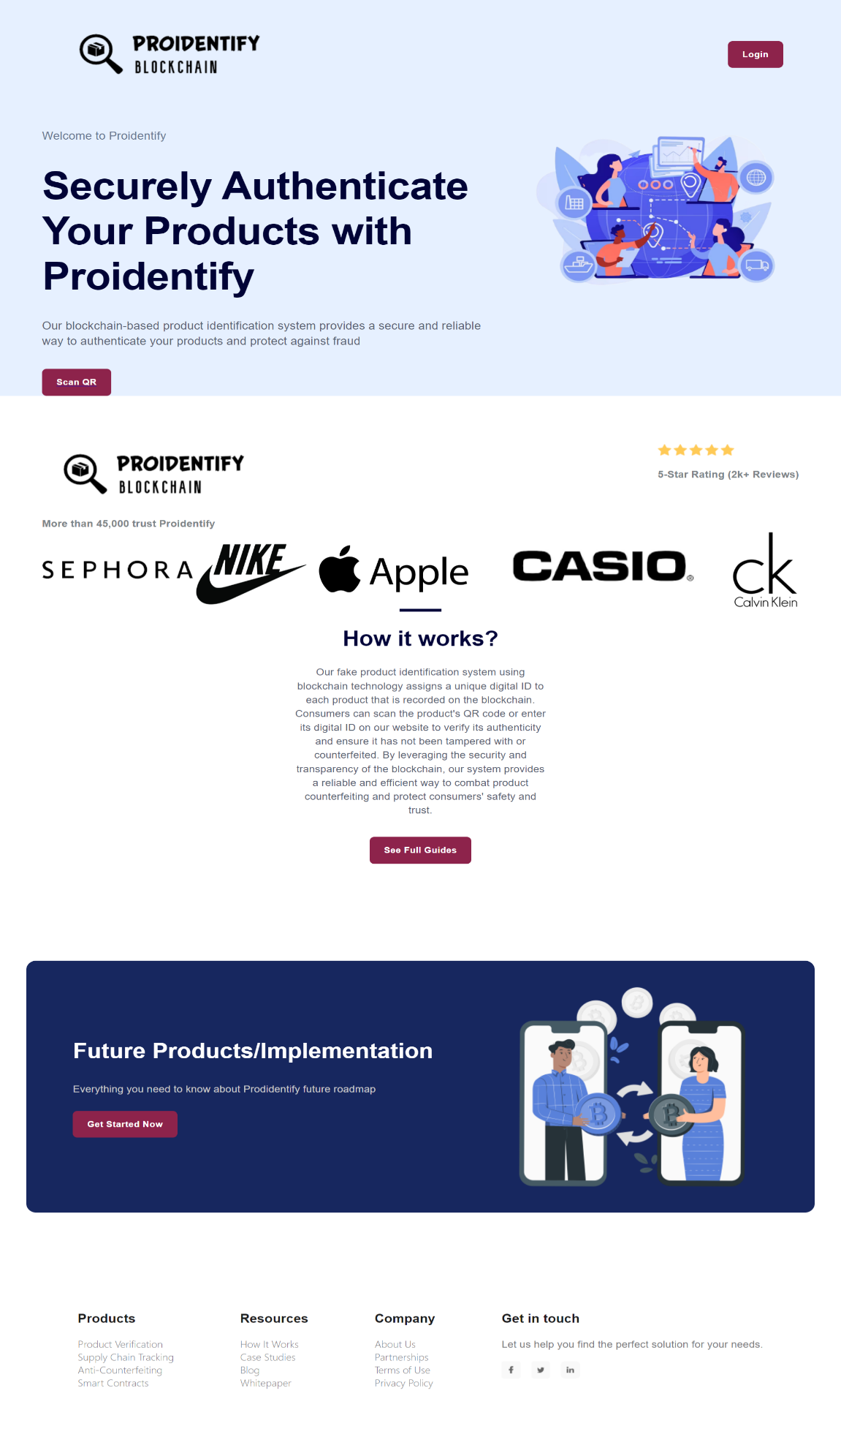

Login Page

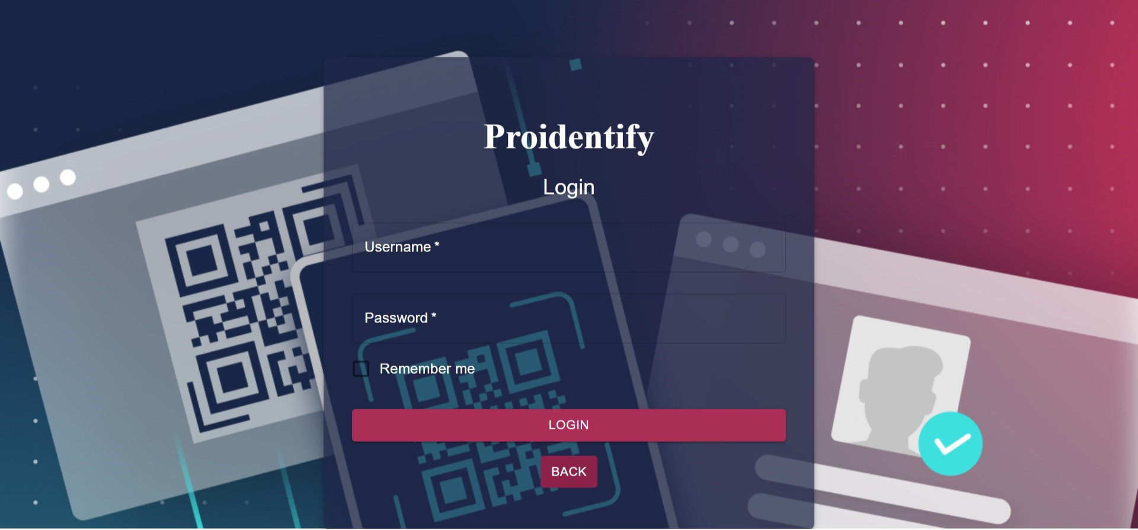

Admin Pages



Add Account

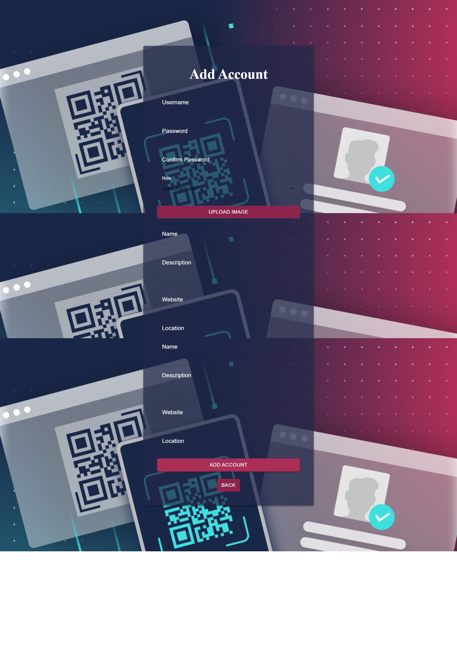

Manage Account

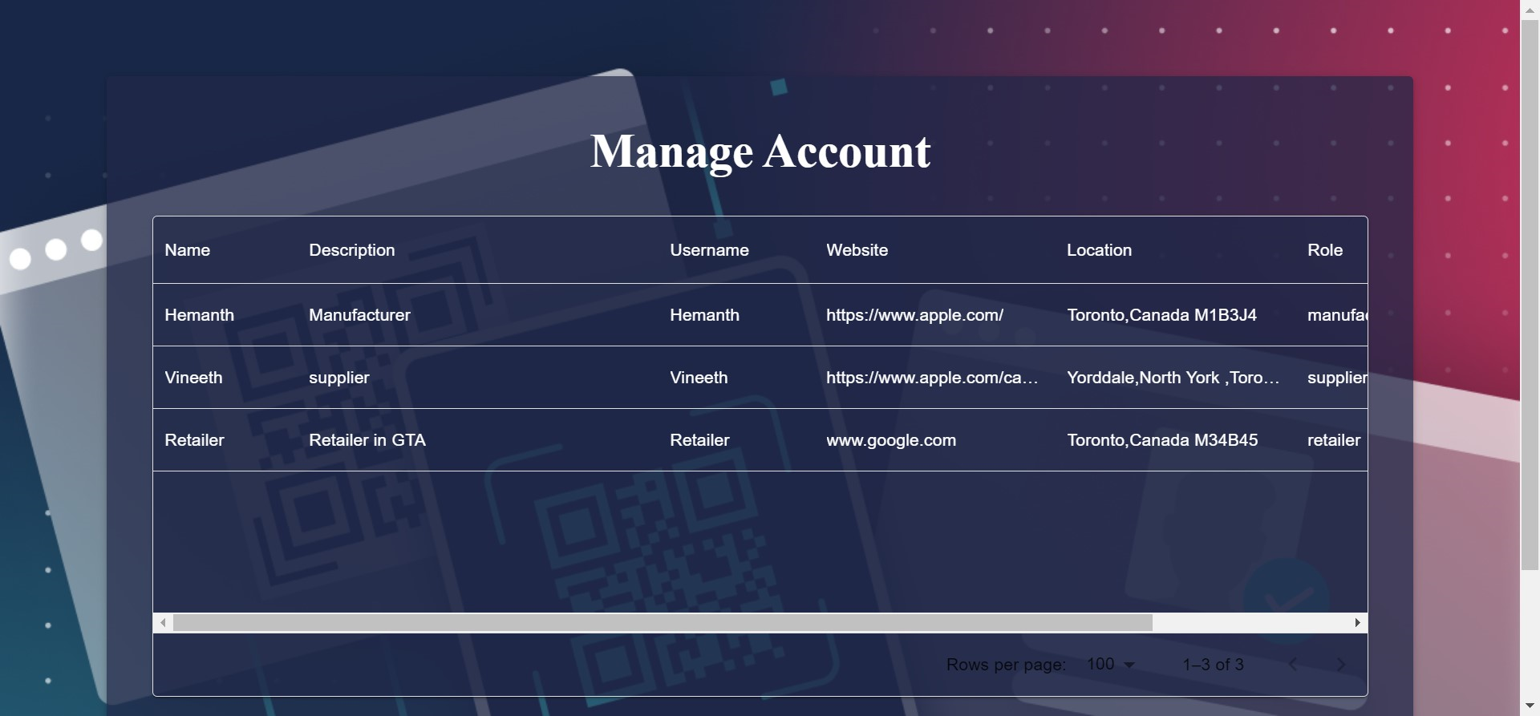

Manufacture

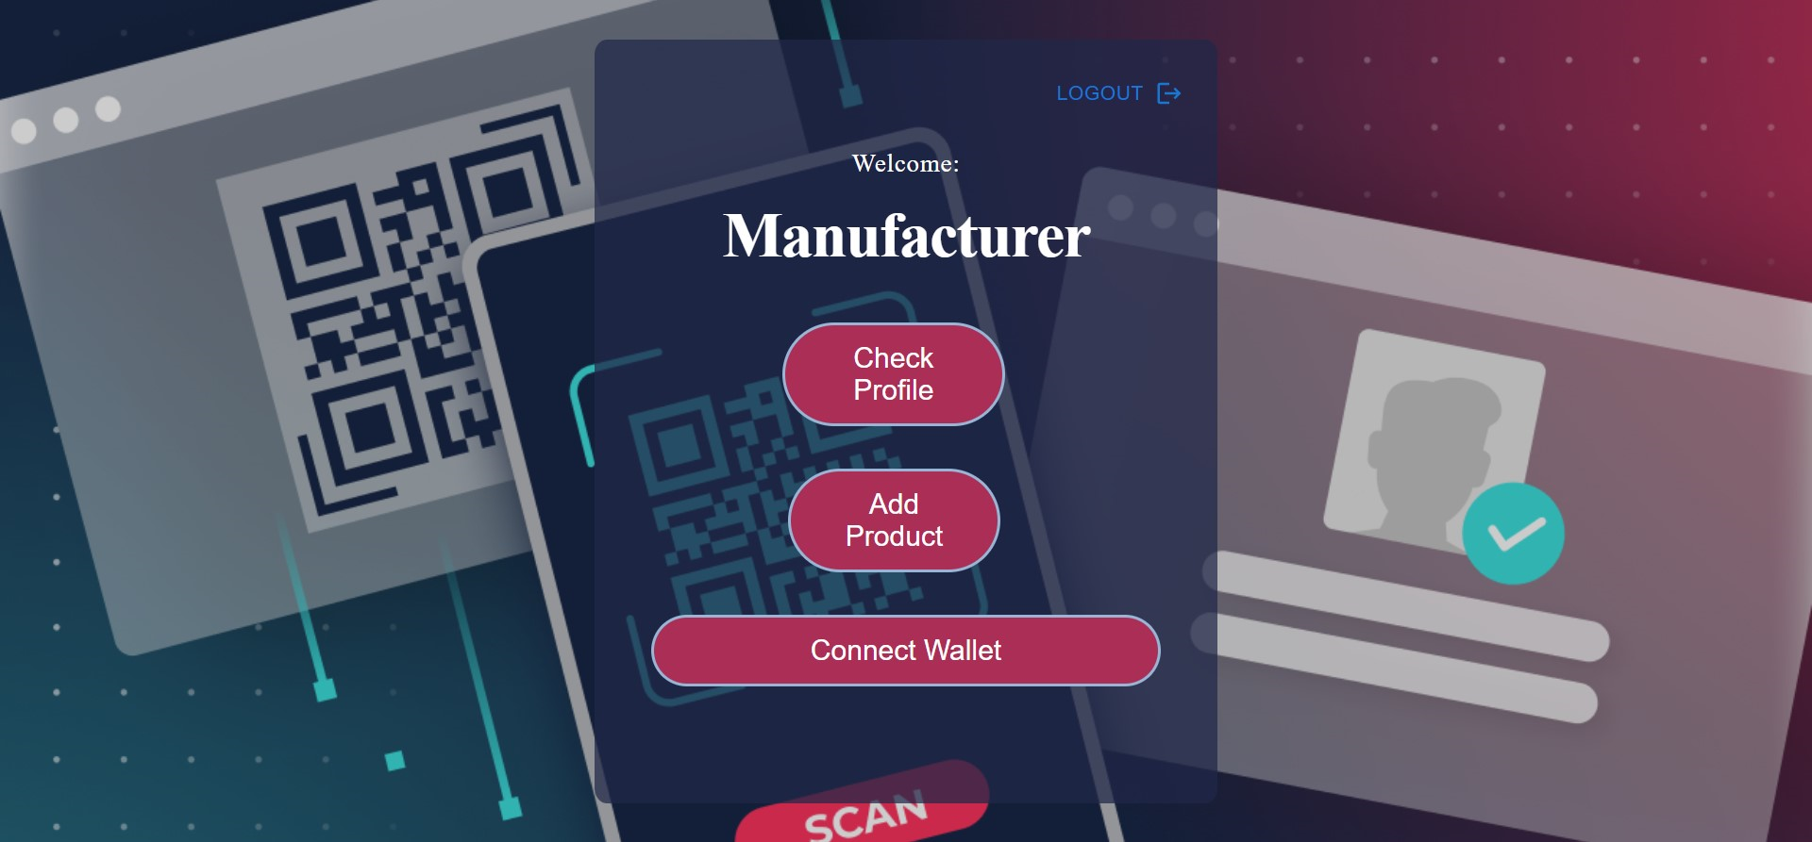

Manufacture

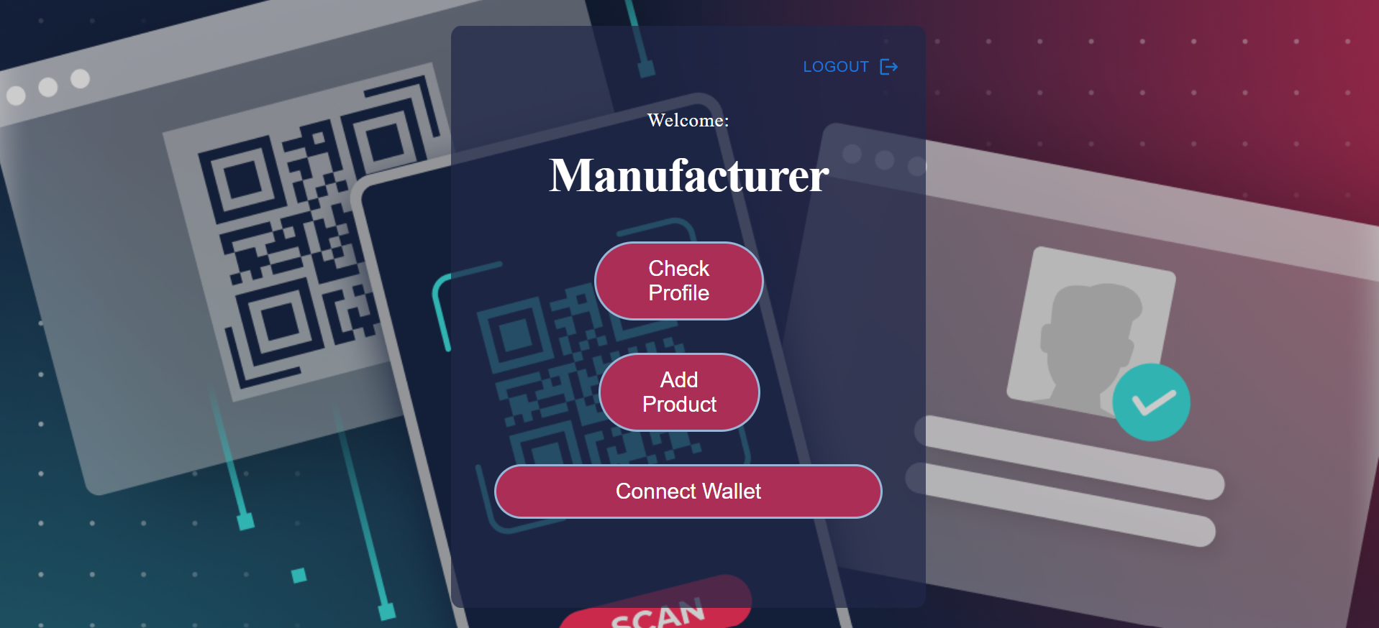

Check Profile for 3 roles

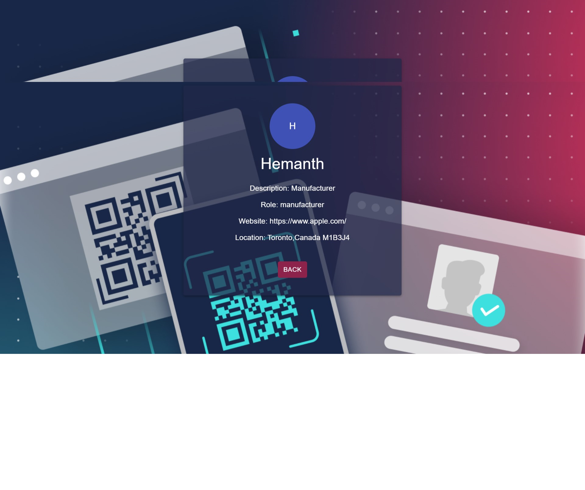

Scan QR code

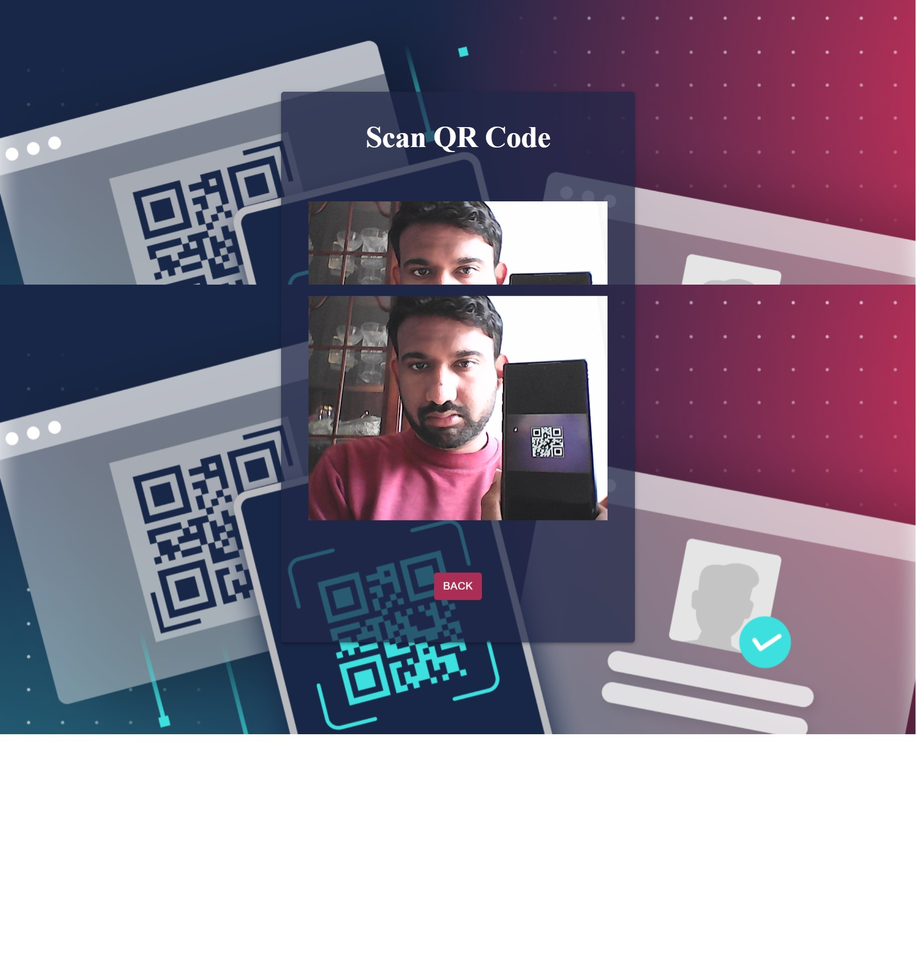

Connect Wallet

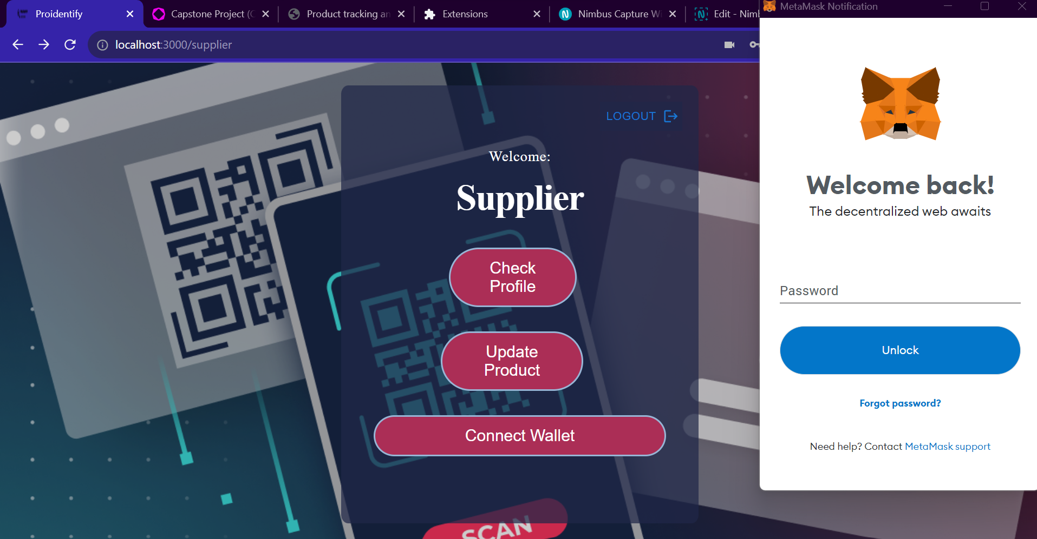

QR scan

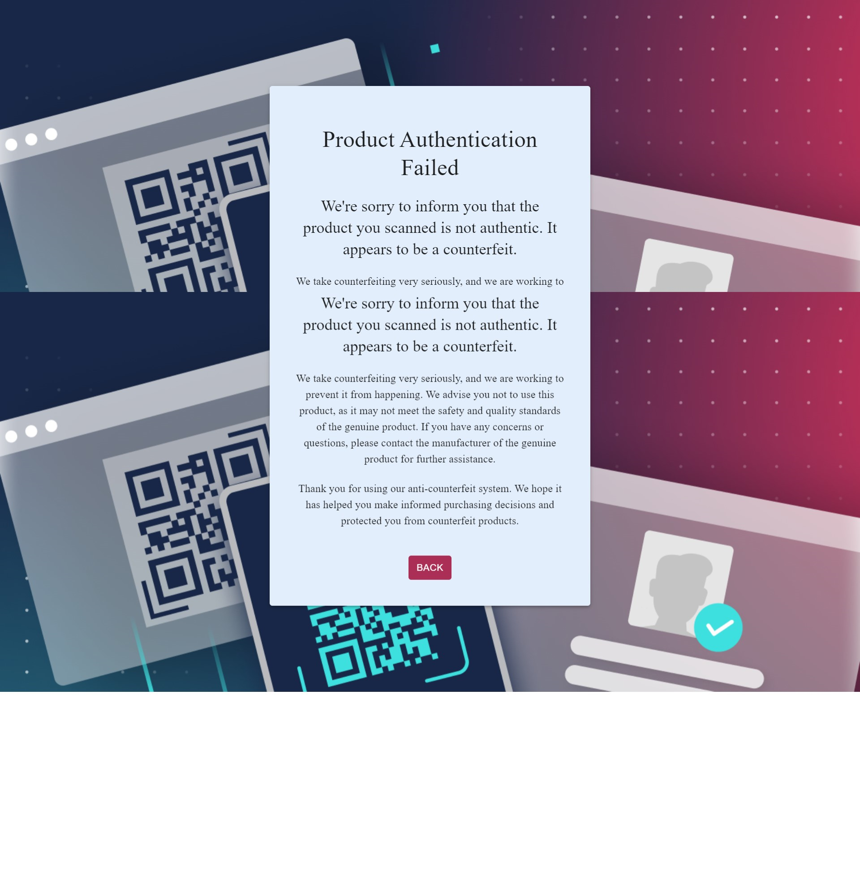

QR code scan

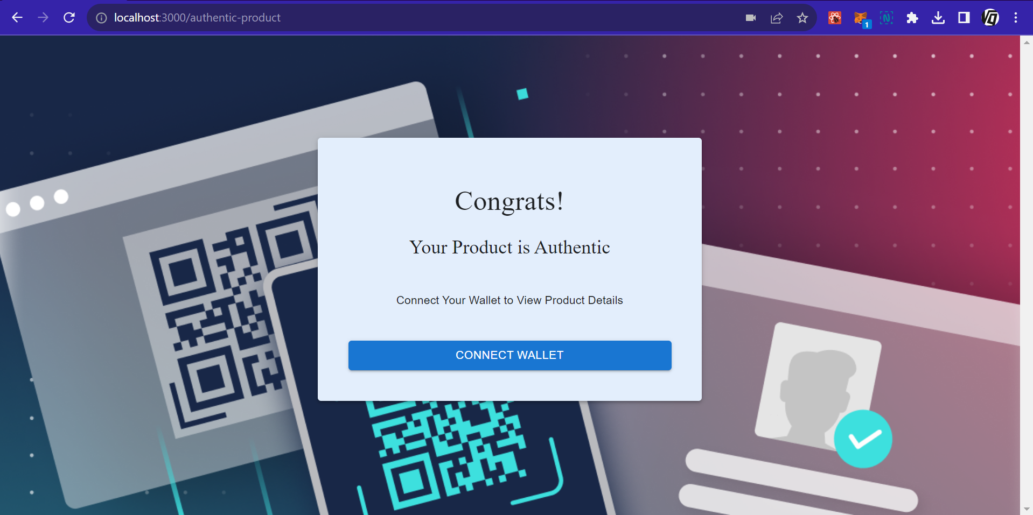

Return of Investment (ROI)

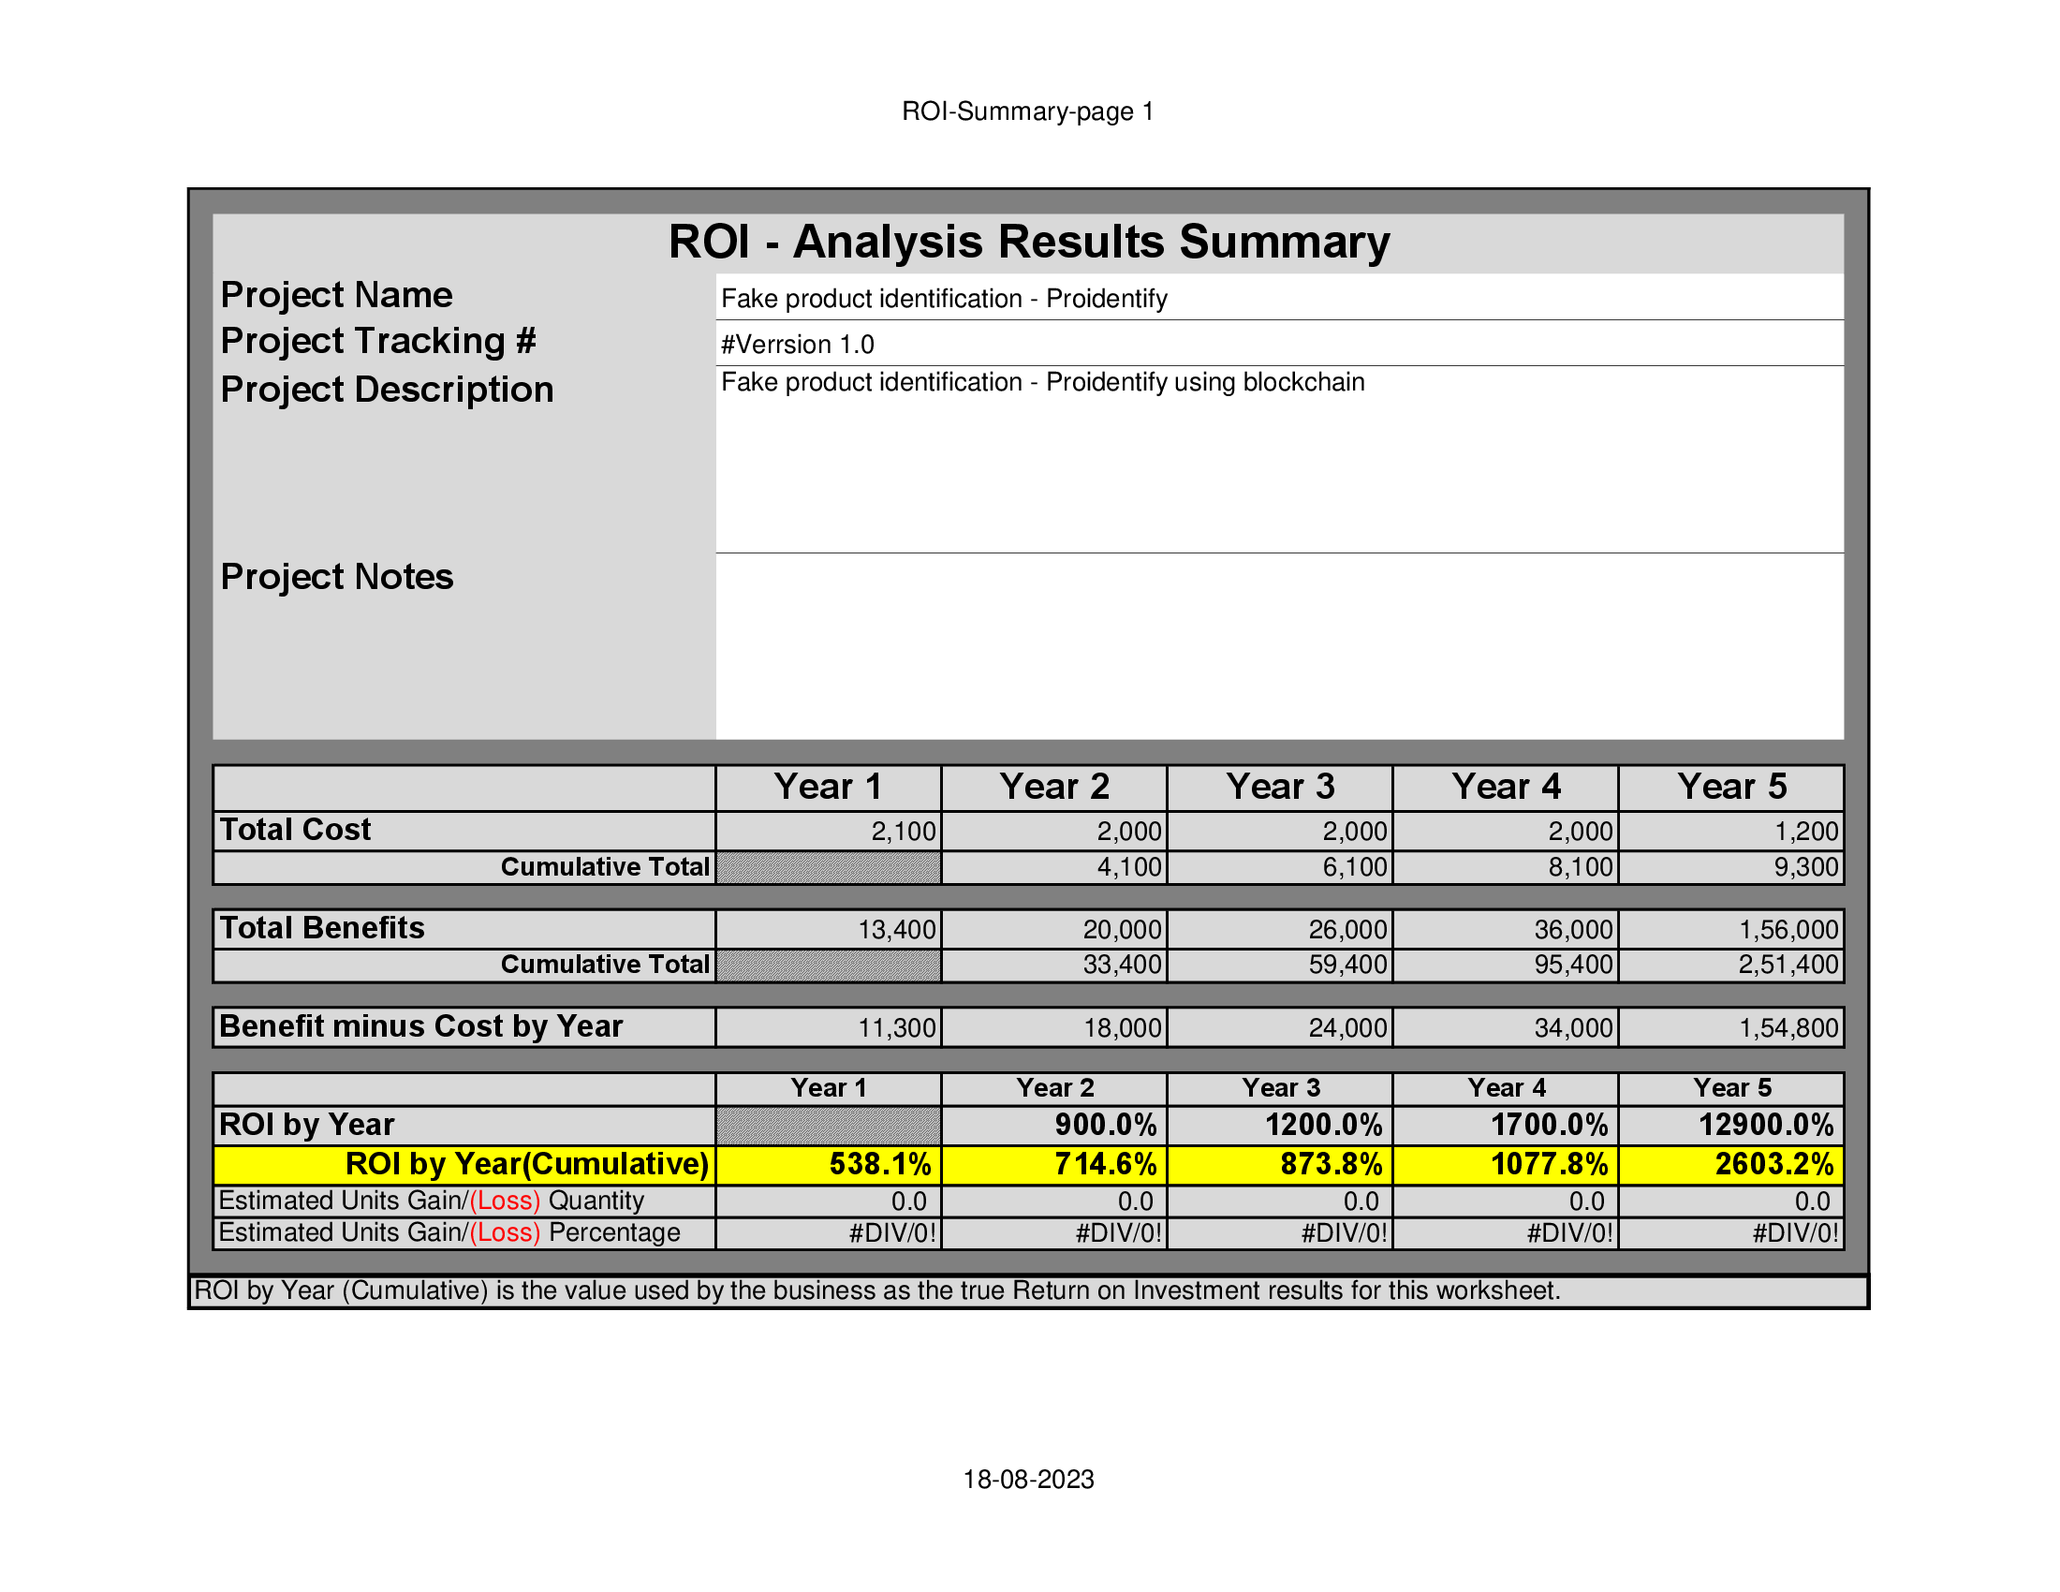

***References***

[1] ASPA, The state of counterfeiting in india 2021, https : / / www.aspaglobal.com / pre_upload / nation / 1623216858-4730baa0efdb83aba174859af0a3a6a5- Report % 20The % 20State % 20of % 20Counterfeiting % 20in % 20India % 202021.pdf (2021)

[2] Y. Lu, Journal of Management Analytics 5, 1 (2018)

[3] F. Casino, T.K. Dasaklis, C. Patsakis, Telematics Informatics 36, 55 (2019)

[4] M. Peck, IEEE Spectrum 54, 26 (2017)

[5] S. Idrees, M. Nowostawski, R. Jameel, A. Mourya, Electronics 10, 951 (2021)

[6] Zignuts Technolab, How blockchain architecture works? basic understanding of blockchain and its architecture., https : / / www.zignuts.com / blogs/ how - blockchain - architecture - works - basic - understanding- of- blockchain- and-its- architecture/ (2022)

[7] J. Ma, S.Y. Lin, X. Chen, H.M. Sun, Y.C. Chen, H. Wang, IEEE Access 8, 77642 (2020) [8] M.J.L.I.N.M. J.M. Bohli, N. Gruschka, IEEE 10, 9 (2013)

[9] C. Shaik, Computer Science & Engineering: An International Journal (CSEIJ) 11 (2021)

[10] M.A. Benatia, D. Baudry, A. Louis, Journal of Ambient Intelligence and Humanized Computing pp. 1–10 (2020)

[11] G. Khalil, R. Doss, M. Chowdhury, IEEE Access 8, 47952 (2020)

[12] M.A. Habib, M.B. Sardar, S. Jabbar, C.N. Faisal, N. Mahmood, M. Ahmad, Blockchain-based supply chain for the automation of transaction process:

13. <https://www.infosys.com/oracle/insights/documents/product-tracking-tracing.pdf>